Mid (2021)

1.
a) Is Empty java file name a valid source file name?
public static void main (String [] args) ---explain this statement. (3 marks)
Sol^{n}:
In Java:
- A source file name must have a valid identifier followed by the .java extension.
- A file with no name (just .java) is not valid.
- The compiler needs a valid identifier for the class
- An empty file name (like just .java) is not allowed by the operating system itself and will not compile.
- For example: Test.java, HelloWorld.java.
Explanation of public static void main(String[] args)
This is the entry point of a Java program, where execution begins.
Keyword | Meaning
public | The method is accessible from anywhere. Required so the JVM can call it.
static | Belongs to the class, not an object. JVM can call it without creating an instance.
void | Does not return any value.
main | Name of the method where execution starts.
String[] args | Parameter that holds command-line arguments as an array of Strings.
1.
b) What is the output of the following Java program? (2 marks)
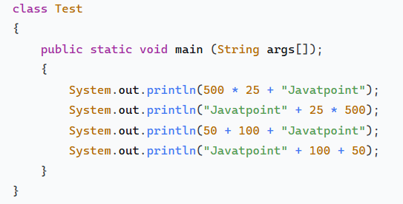
Sol^{n}:
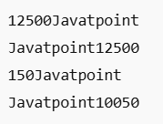

1.
c) Write a program in Java to print such pattern like right angle triangle with number increased by 1. The pattern like: (3 marks)
1
2 3
4 5 6
7 8 9 10
Sol^{n}:
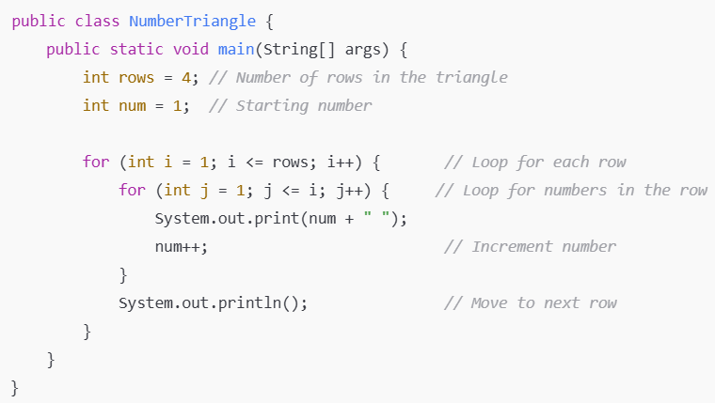

2.
a) Why multiple inheritance is not supported in java through class? (2 marks)
Sol^{n}:
Multiple inheritance through classes is not supported in Java mainly to avoid ambiguity and complexity, specifically the “Diamond Problem.”
If a class inherits from two classes that have a method with the same signature, the compiler cannot decide which method to use. This leads to ambiguity – Dimond Problem
By not allowing multiple inheritance through classes, Java avoids complexity and keeps the inheritance hierarchy clear.
Java allows multiple inheritance through interfaces, which avoids this ambiguity because interfaces only declare methods without providing implementation.

2.
b) How is Inheritance achieved in Java? (2 marks)
Sol^{n}:
In Java, inheritance is achieved using the extends keyword for classes and implements keyword for interfaces:
- Class Inheritance: A class can inherit fields and methods from another class using extends.
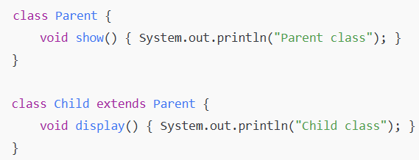
- Interface Inheritance: A class can implement an interface using implements, allowing it to provide behavior defined in the interface.
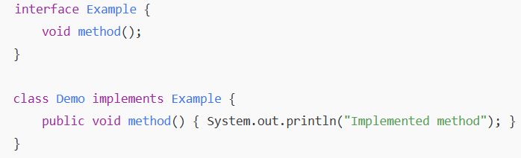

2.
c) Will the following code be successfully compiled? If yes, what is the output? (3 marks)
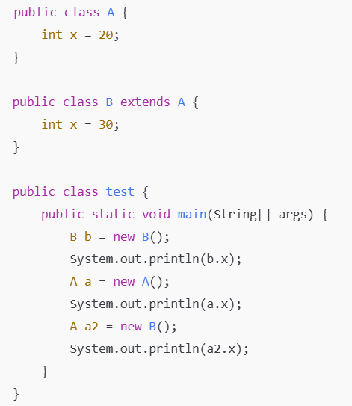
Sol^{n}:
Compilation check
- Problem: In Java, you cannot have more than one public class in the same .java file.
- In Java, only one public class is allowed per file, and the file name must match that class.
- Here, you have public class A, public class B, and public class test all in the same file. This will cause a compilation error.
- Fix: Either remove the public keyword from A and B, or split them into separate files named A.java, B.java, and test.java.
So, as-is, this code will NOT compile.

